Flight Dynamics Users Guide

Table of Contents

A new Flight Dynamics Project 2

Running the Flight Dynamics Tool 6

Basic Trim Settings (Recommended for ease of use) 6

Advance Trim Settings 7

Viewing Results 9

Creating a New Analysis Task 10

# A new Flight Dynamics Project

1. Launch the tool. 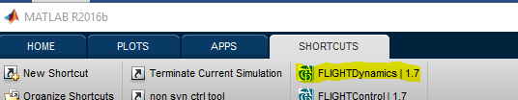
2. Select “Create New Project”. 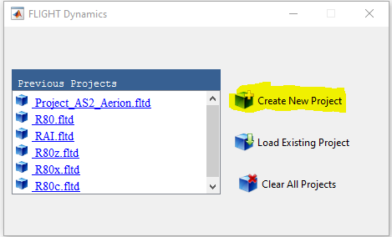
3. Give the Project a name. 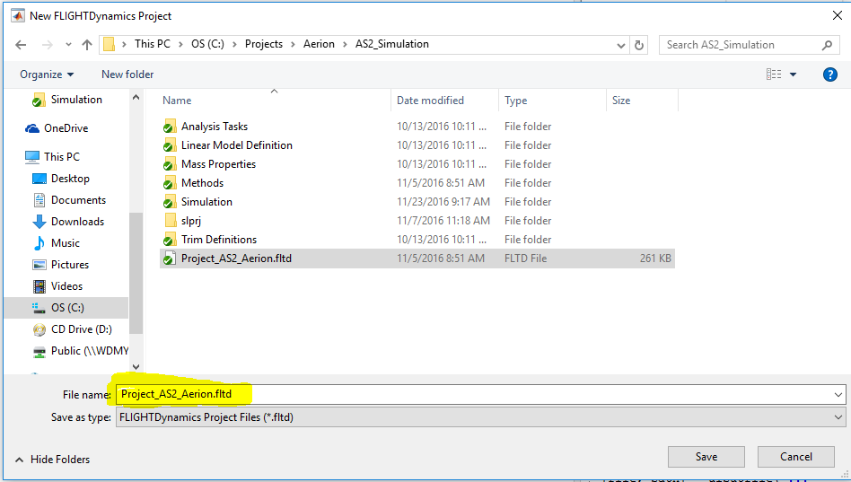
4. In the Tree – Right click Simulation and select “Add Model”. 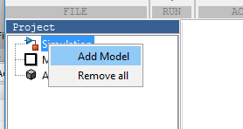
5. Remember to set the correct simulation units. Default is “English- US”. 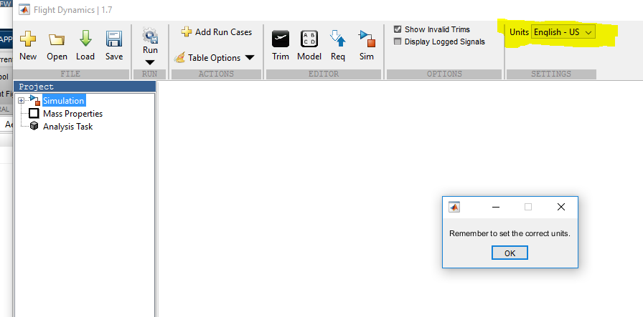
6. In the Tree – Right Click Mass Properties and select “Insert Mass Properties Definition” 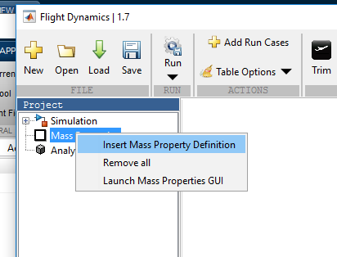
   1. Mass Propeties files must be defined as shown below with tab seperated columns and corresponding headers. 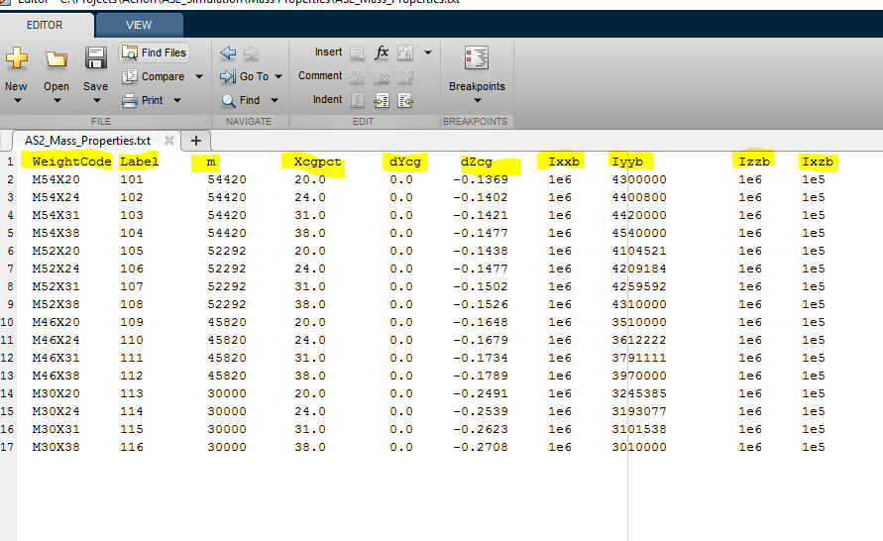
   2. Mass Properties files can also be an expoted mat file from the tool.
7. Using an exisitng analysis task : In the Tree – Right Click Analysis Task and select “Insert Analysis Task” – MULTIPLE CAN BE ADDED

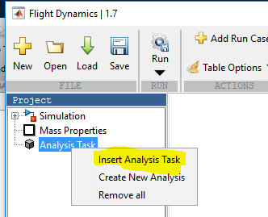

1. Creating a new analysis task : In the Tree – Right Click Analysis Task and select “Create New Analysis” ( See appendix – Creating Analysis Tasks)

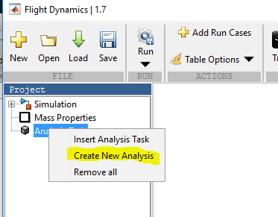

1. Now the project is set up!

# Running the Flight Dynamics Tool

## Basic Trim Settings (Recommended for ease of use)

1. Flight condition.
   1. Select the flight condition units.
   2. Input the flight condition using a scalar or standard Matlab vector format. Must be a 1 x N numeric where N is greater than 1. N will be the number of trim conditions run.

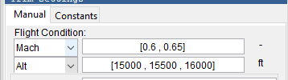

1. Input flap and gear settings.

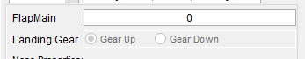

1. Select the mass properties that will be used for the trim.

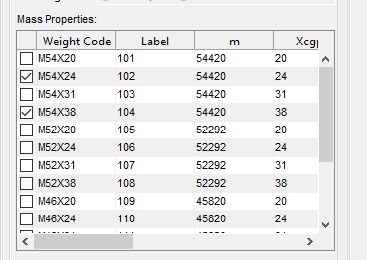

1. Set any conditions for the simuilation inputs/outputs for both trim 1 and trim 2. The values may be scalar or standard Matlab vector format. Must be a 1 x N numeric where N is greater than 1. N will be the number of trim conditions run

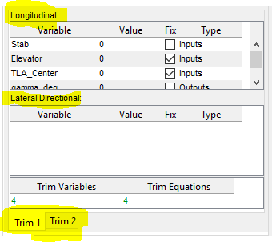

1. Add a label to the group of trims.



1. Run Trim or Continue to build your trim case
   1. If you are ready to run hit the “Run”  button in the tool bar
   2. To continue to build your trim you can hit “Add Run Cases”  in the toolbar.

## Advance Trim Settings

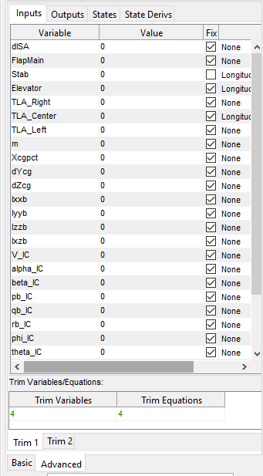

In the advanced section the user may use any configuration.

It is diveded up into two main trim tabs and each trim tab is then diveded into four sections ( Inputs, Outputs, States, StateDerivs), the parameters in each section corespnd to their respective location withing the simulink model.

Again, The values may be scalar or standard Matlab vector format. Must be a 1 x N numeric where N is greater than 1. N will be the number of trim conditions run.

To assist the user in selecting the correct number of trim equations, the selected number of Trim Variables and Trim equations are displayed. They must be equal.

# Viewing Results

Depending on the number of analysis task loaded into the tool, you may have multiple tabs in the results area. Each one corresponds to the analysis task load into the tree.

# Creating a New Analysis Task